Best Practices Application
Andrew Galvez

Project Selection
Project description: I am continuing a personal software project that combines a Wails desktop automation platform, a Go backend task engine, and AI-assisted prototyping workflows using Claude, Codex, and MCP-connected tools. During the project period, I am documenting architecture, improving request-based workflow performance, building and testing modules, and collecting visual evidence of progress.

Project and Resource Links
• GitHub profile / portfolio location : use this for repository or portfolio evidence when the project is ready to show safely.
• Wails documentation : use for the Go + desktop application framework used in the project.
• Go documentation : use for backend language and testing references.
• React documentation : use for the frontend portion of the Wails app.
• Roblox Creator documentation : use for the Roblox prototype evidence connected to AI-assisted product building.
• Blender documentation : use for 3D asset/prototyping evidence connected to the Blender MCP workflow.
• OWASP Web Security Testing Guide : use as the ethical web application security-testing reference.
• Dissecting Shape Security's Virtual Machine : Great article for reverse engineering shape
• Shape Security's JavaScript VM: Part 1, Part 2, & Part 3 : More great articles for reverse engineering shape

Why this project matches the best practice
• It applies the “build real-world projects” best practice because the work goes beyond a class assignment and shows backend architecture, frontend visibility, workflow automation, debugging, and documentation.
• It applies the “develop a strong portfolio” best practice because the evidence can show project purpose, architecture, commits, tests, progress logs, and screenshots without requiring the instructor to inspect sensitive implementation details.
• It supports the job-package theme because Palantir, Affirm, and Toast all reward project evidence that demonstrates systems thinking, product iteration, AI-assisted development, and responsible handling of technical complexity.

Project Evidence
• Evidence of token activity from past few months (Codex)
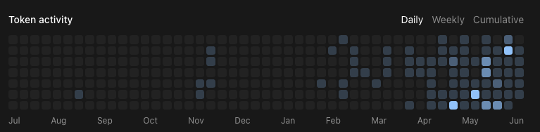
• Evidence of using Claude to research windows kernel drivers via IDA MCP
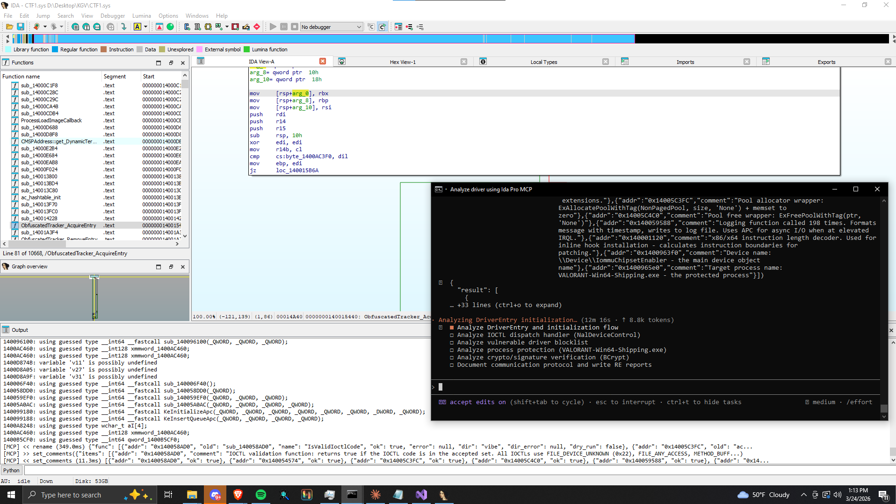
• Evidence of using Codex with Roblox studio and Blender MCP’s
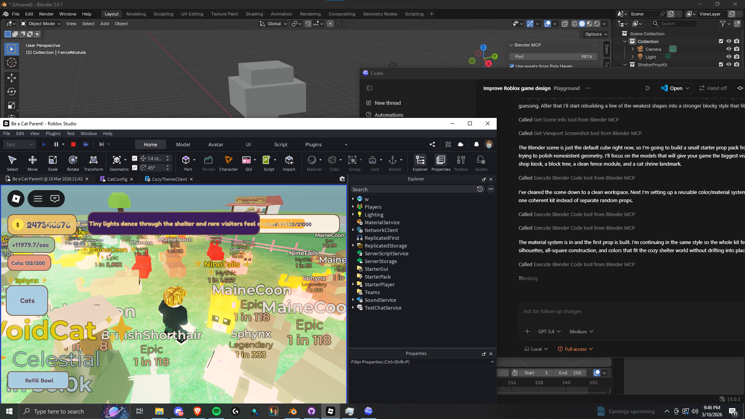
• Evidence of the Automated Checkout Software successfully reaching a payment decline on a product using fake card information, using my built shape API for header generation rather than relying on a browser.
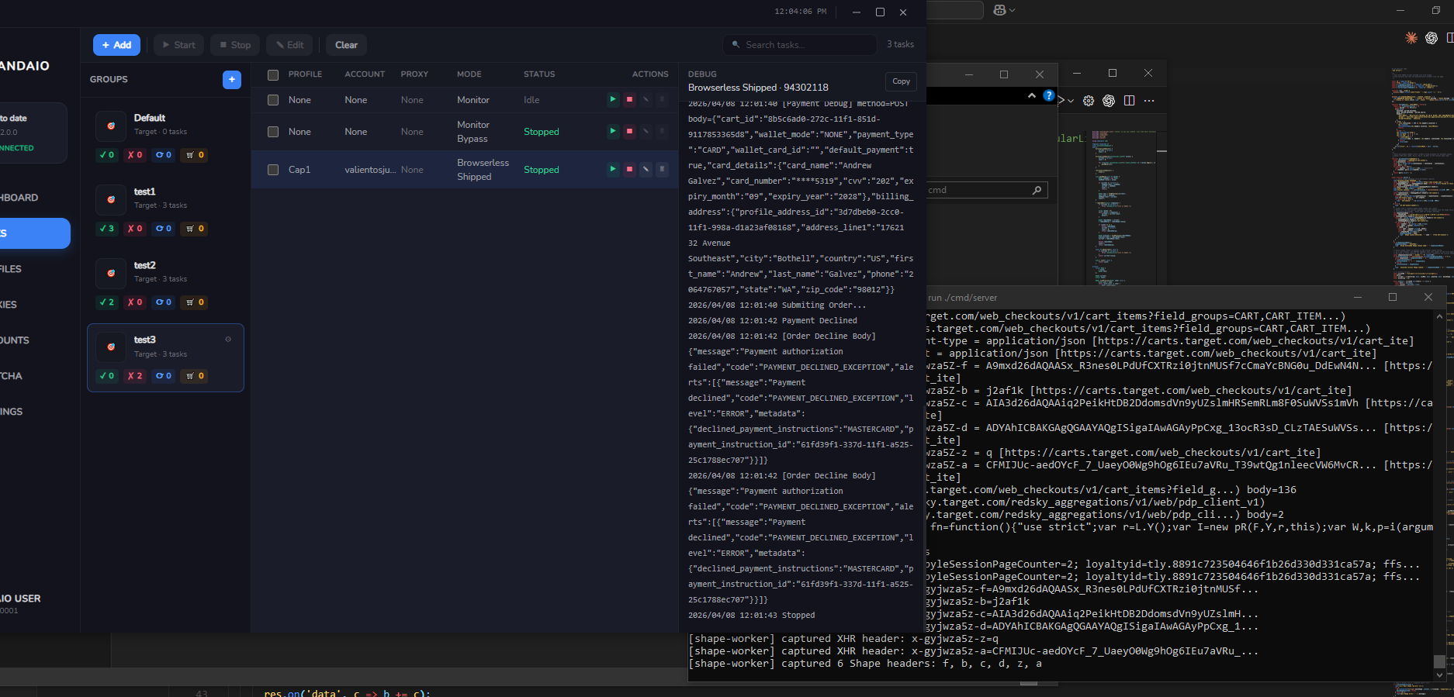

Github Repo to Wails, React, Go app + shape API
https://github.com/andre4wDev/RevenueSoftware26
Github Repo to Veckage, C++ project involving research into the Windows Kernel and Kernel driver development
https://github.com/andre4wDev/Veckage

Project Diary: Inductive Entry 1
Diary Entry 1: Turning a private project into responsible evidence
During the first project week, I worked on narrowing my personal software project into evidence that could support my software engineering job search.

At the beginning
At the beginning of the week, the hardest part was not the coding itself as I have been working on my personal projects since before this. The harder part was deciding how to explain the project without exposing sensitive implementation details. My automated workflow platform includes a Wails desktop app, a Go backend, and a research API, so there was a lot I could show. However, I quickly realized that not every technical detail belongs in the class submission or a portfolio. That made the project feel more complicated than I expected, because I had to think like both a builder and a responsible communicator.

By the middle
By the middle of the week, I shifted my focus from showing everything to showing progress clearly. I outlined the architecture, separated the app into frontend, backend, task engine, monitor, and research components, and started planning screenshots that use mock card data. This helped me see that evidence does not need to reveal private logic to prove that I am working. A clean diagram, Codex token history, test output, and screenshots can show the same growth more professionally. (I would use GitHub commit history, but this project exists only locally.)

Conclusion
Looking back, this week showed me that strong technical evidence depends on judgment, not just effort. I learned about myself that I need to define boundaries before I decide what to show. Now I will build portfolio evidence in a way that proves progress while protecting sensitive work and respecting the systems I study.
[Word Count: 248]

Project Diary: Inductive Entry 2
Diary Entry 2: Learning how to use AI without losing ownership
During the second project week, I worked on using AI-assisted tools to speed up prototyping and systems analysis while keeping ownership of the final decisions.

At the beginning
At the beginning of the week, I felt excited by how much the AI tooling could connect together. I used Claude and Codex with MCP-connected tools while working across Roblox Studio, Blender, and IDA. The Roblox and Blender workflow helped me experiment with a game prototype called “Be a Cat Parent,” while the IDA workflow helped me organize driver-analysis notes in a controlled research setting. The success was that I could move faster across unfamiliar tools without stopping every time I needed a new workflow or explanation.

The struggle
The struggle was that speed created a new kind of responsibility. AI could suggest code, summarize behavior, or help generate assets quickly, but it could not decide what was safe to include in evidence or what needed verification. I had to slow down, review the output, and decide whether the result matched the project’s purpose. That changed how I thought about AI. It was not a shortcut around engineering judgment, it was useful only when I gave it a clear scope and verified the result.

Conclusion
Looking back, this week helped me become more confident and more cautious at the same time. I learned about myself that I work best with AI when I treat it as a fast collaborator, not an authority. Now I will use AI tools to accelerate exploration while relying on tests, documentation, and ethical boundaries to decide what actually belongs in the project.
[Word Count: 259]

